Risk Profiler

Data By:

Area Scenario Training Download About Contact

# Scenario Catalogue

Scenario Catalogue

Back to All Scenarios

Scenarios Affecting Vancouver

New? Take The Tour

Sort By:

Magnitude

Filter By:

Magnitude

Reset

Risk Layer

Scenario Name

Magnitude: 4.3

Deaths: 4,323

Dollars: $1,990,999

Damage: 45 days

Adjust Opacity

Legend

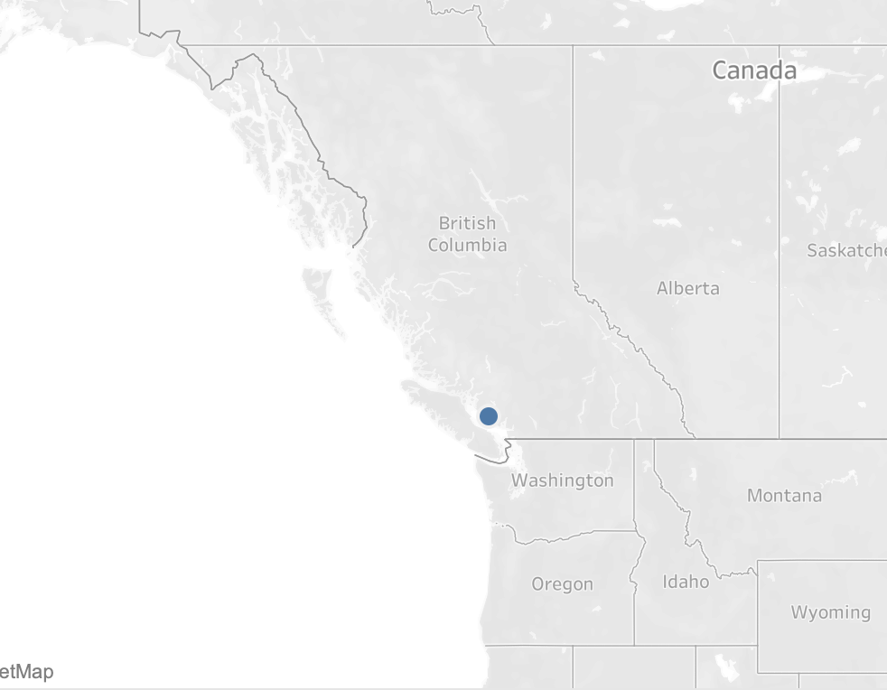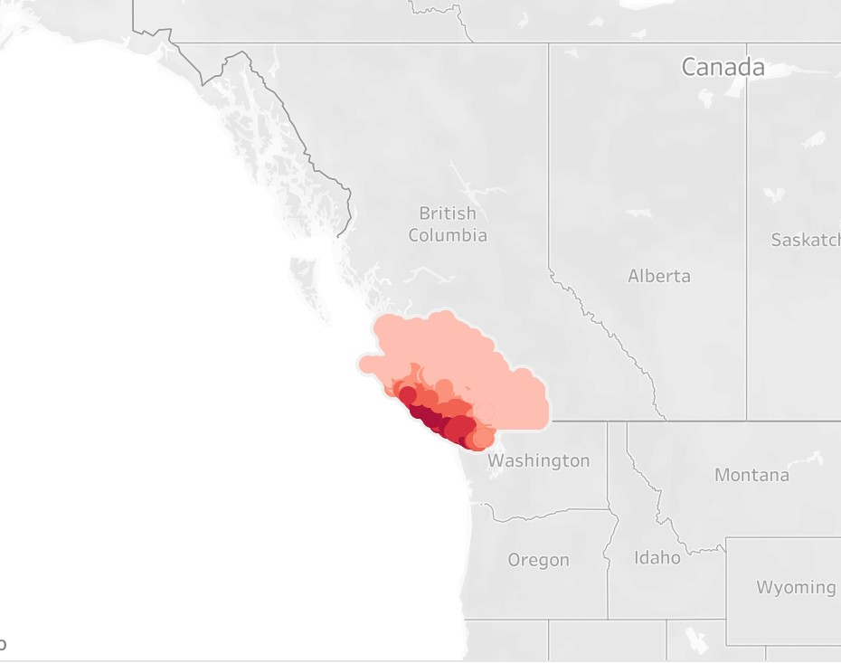

Scenario Name

Magnitude: 5.3

Deaths: 5,443

Dollars: $11,790,999

Damage: 45 days

Scenario Name

Magnitude: 2.6

View Scenario Details

Deaths: 4,998

Dollars: $19,990,999

Damage: 21days

Scenario Name

Magnitude: 3.7

Deaths: 2,982

Dollars: $3,000,000

Damage: 15 days

**-**

Footer